Produce evidence of having professionally relevant FIVE (5) of the following online: blog, vlog, Facebook account,
twitter account, Instagram account, WhatsApp account, LinkedIn account, etc.

- My Linkedin Account: https://www.linkedin.com/in/tony-kimathi-bb7478223/
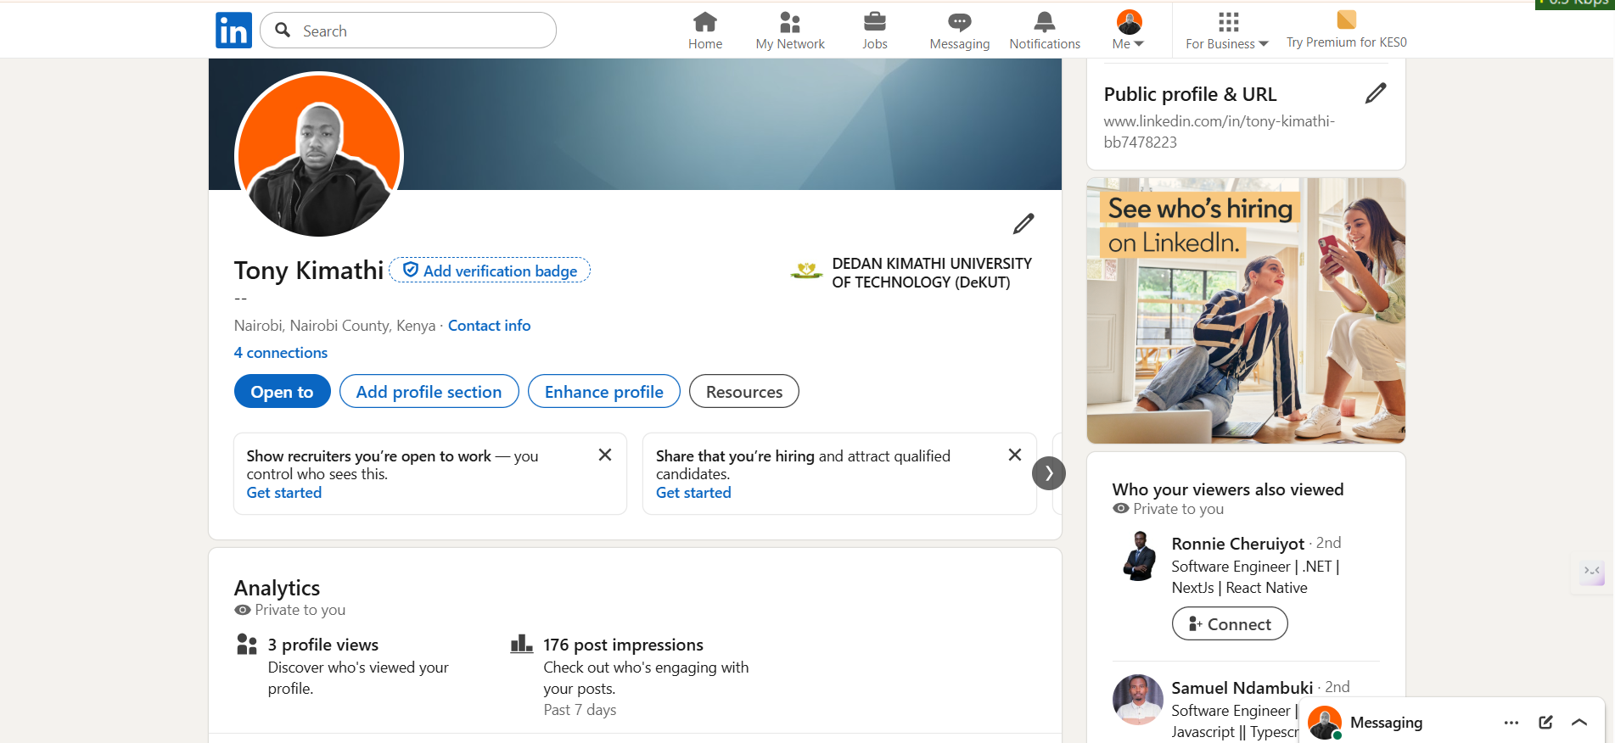
- My Twitter Account:
https://x.com/Brian17173042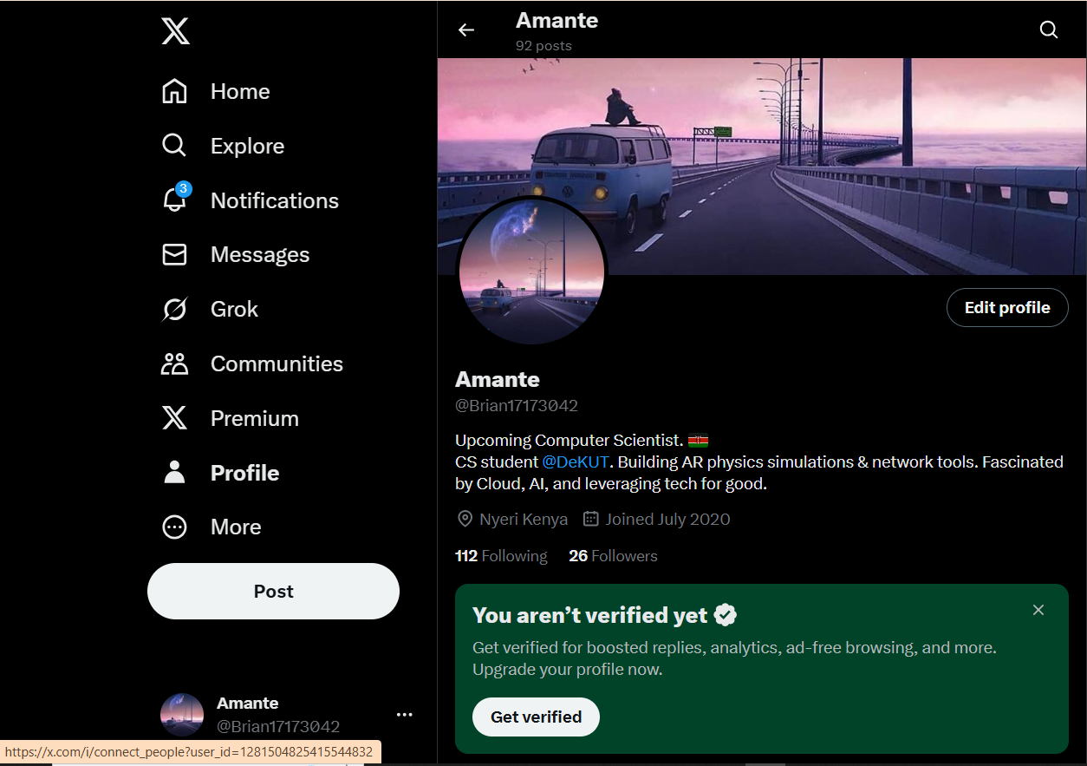
- My Github Account - https://github.com/tonyb8121?tab=repositories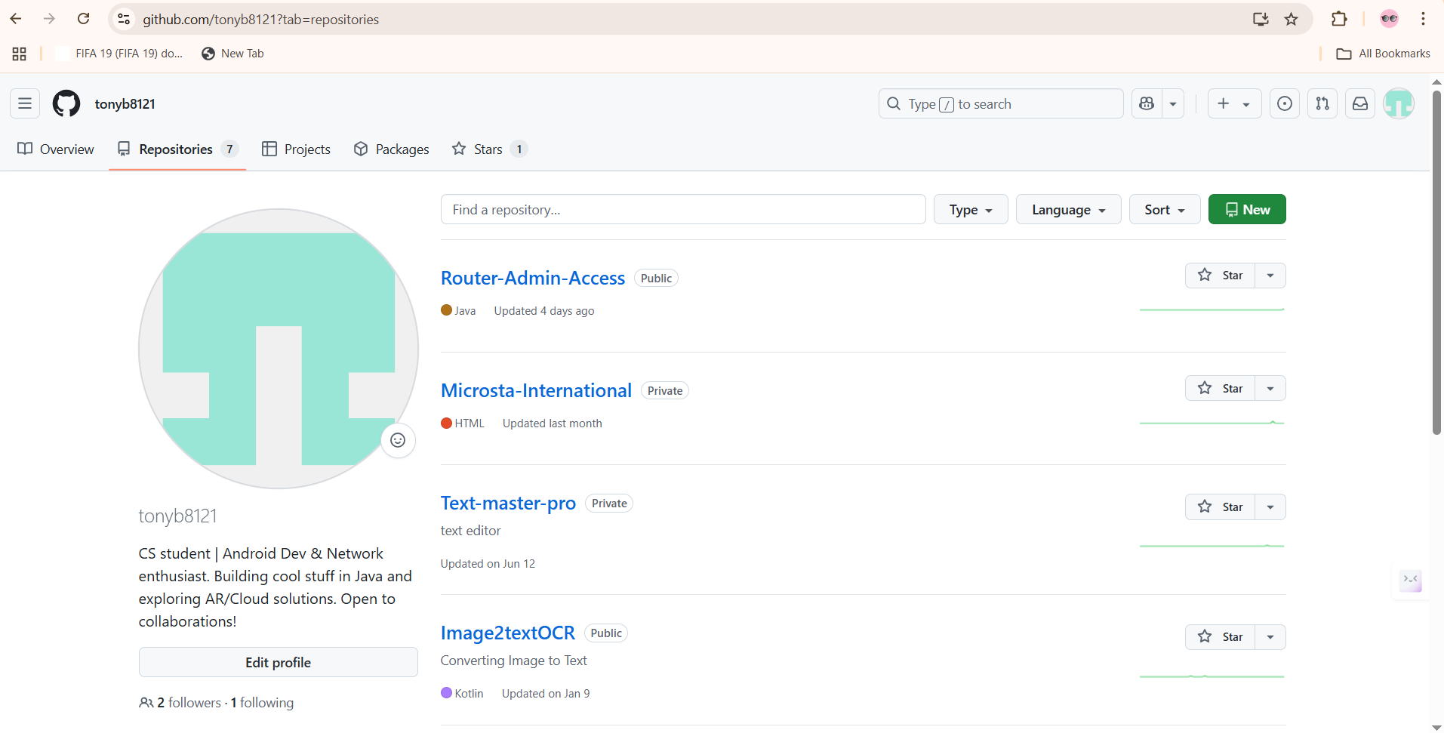
- My Leetcode Account : https://leetcode.com/u/amante12/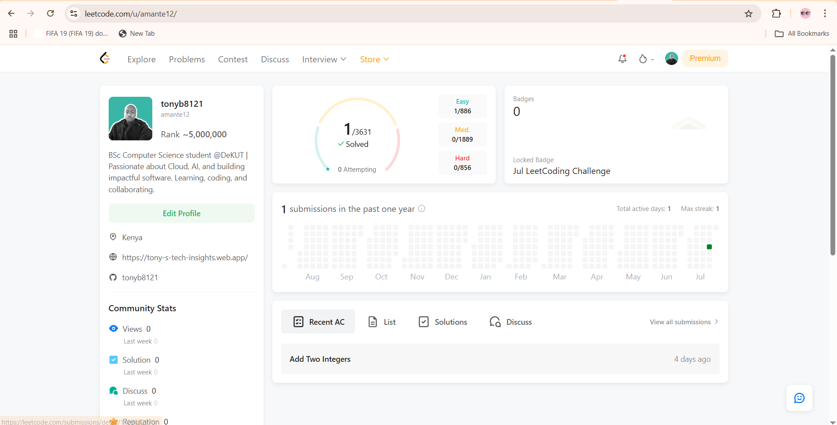
- My Personal Blog:
https://tony-s-tech-insights.web.app/